SHAKESPEAREAN CABARET PRESENTS…
‘PETTY TYRANT’
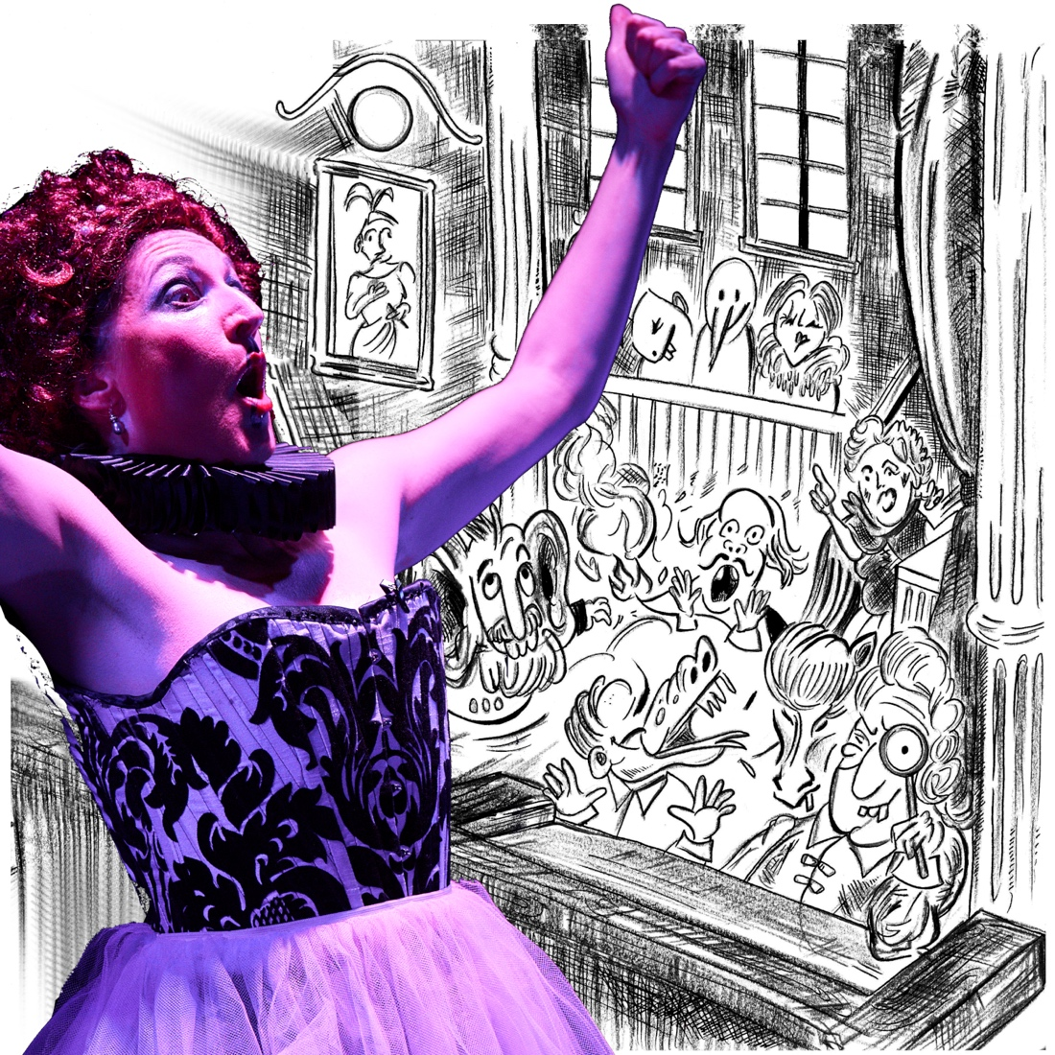
CONTACT
Name: carla kissane (WRITER, PERFORMER, PRODUCER)
EMAIL: shakespeareancabaret@gmail.com / PHONE: +1(646)-617-6793
WEBPAGE: https://www.shakespeareancabaret.com/pettytyrant
ARTIST WEBSITE: https://www.carlakissane.com
PETTY TYRANT SIZZLE REEL HERE

ABOUT THE SHOW
Order in the Court!
Join 'Carlotta-B-from-1593’
The Ultimate Feminist Shakespearean Contemporary Leading Lady in…
PETTY TYRANT
An unorthodox trial of the authorship question
and extravagant hallucination of Shakespearean proportions.
Welcome to an autocratic universe where silence is violence
and controlling the narrative is victory.
Is Shakespeare a TYRANT? Or is he just… PETTY…
You will decide the verdict, and live jazz band ‘The Executioners’ will keep time
Proving beyond reasonable doubt
That the gatekeepers are guilty and the evidence isn’t stacking up.
It’s ‘Judge Judy’ meets ‘The Apprentice’ with Shakespeare and live jazz
Starring ‘Carlotta-B-from-1593’ as Anonymous Chirrullus Battillus;
The Original Badass Bitch.

Produced by Shakespearean Cabaret, Written and Performed by Carla Kissane (AEA, SAG-AFTRA), Musical Arrangements by Marius Van Den Brink Original dramaturgy by Theodor Gabriel. PETTY TYRANT is made possible by the New York State Council on the Arts with the support of the Office of the Governor and the New York State Legislature.
FIND SHAKESPEAREAN CABARET
WEBPAGE: https://www.shakespeareancabaret.com/pettytyrant
WEBSITE: https://shakespeareancabaret.com/
INSTAGRAM: https://www.instagram.com/shakespeareancabaret/
Link Tree: https://linktr.ee/shakespeareancabaret
PETTY TYRANT INSTAGRAM PROMO REELS HERE
PETTY TYRANT SIZZLE REEL HERE
DONATE: https://fundraising.fracturedatlas.org/shakespearean-cabaret-co
SAMPLE advertising POSTERS BELOW!
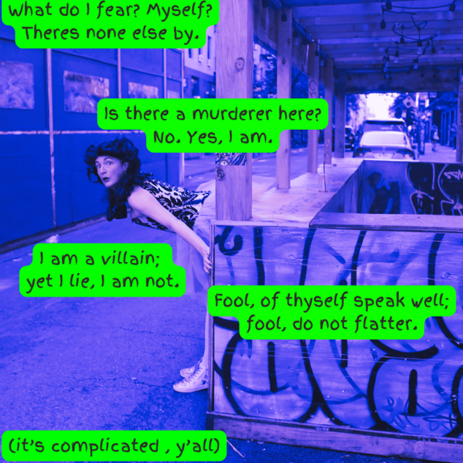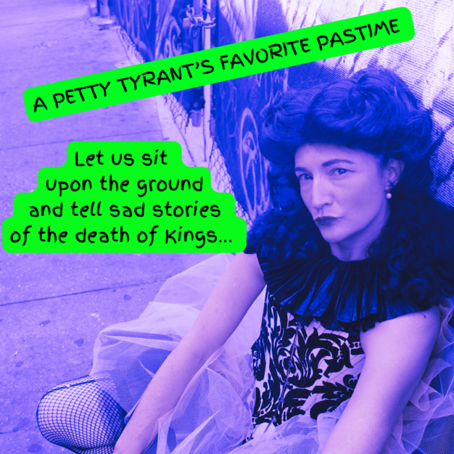
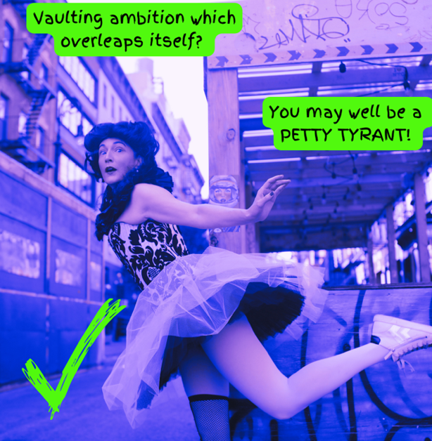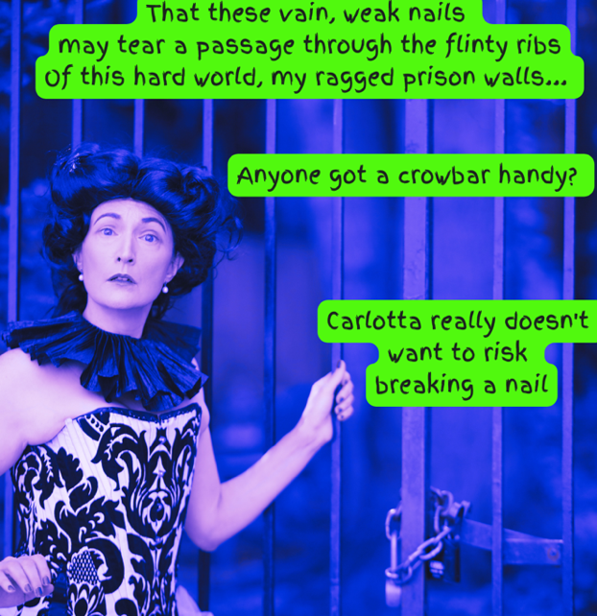
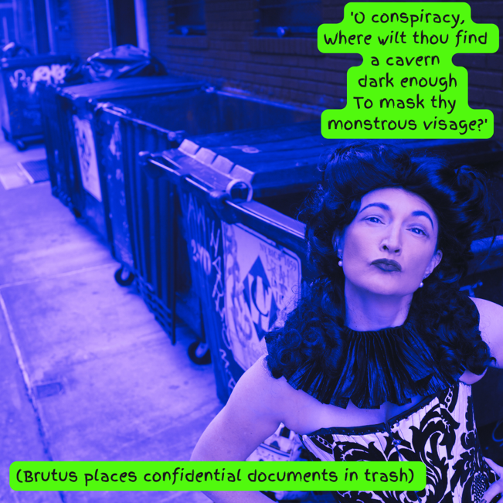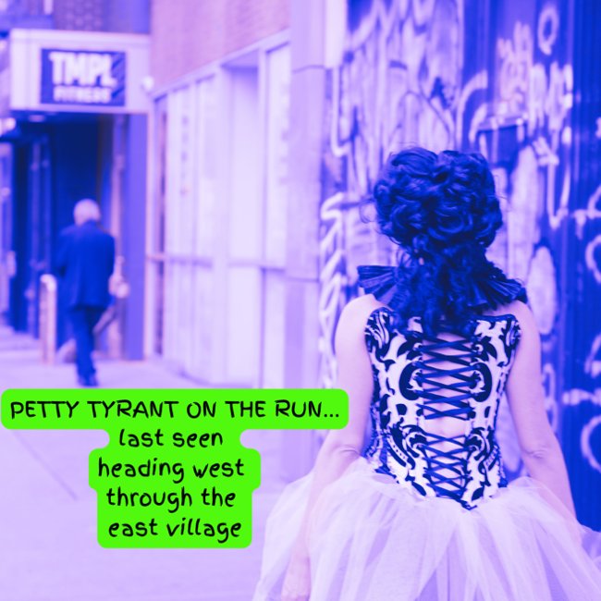
SHAKESPEAREAN CABARET MISSION STATEMENT
Carlotta believes in the power of words to be wielded as a weapon to speak truth to power. She is devoted to the development of new works which highlight the satirical nature of Shakespearean text. By interrogating the language and the structures and systems of thought that pervade our belief systems and cultural landscapes today, 'The Ultimate Feminist Shakespearean Contemporary Leading Lady' shows us how to hold up the mirror to nature in the most frank, poetic and lyrical of ways.
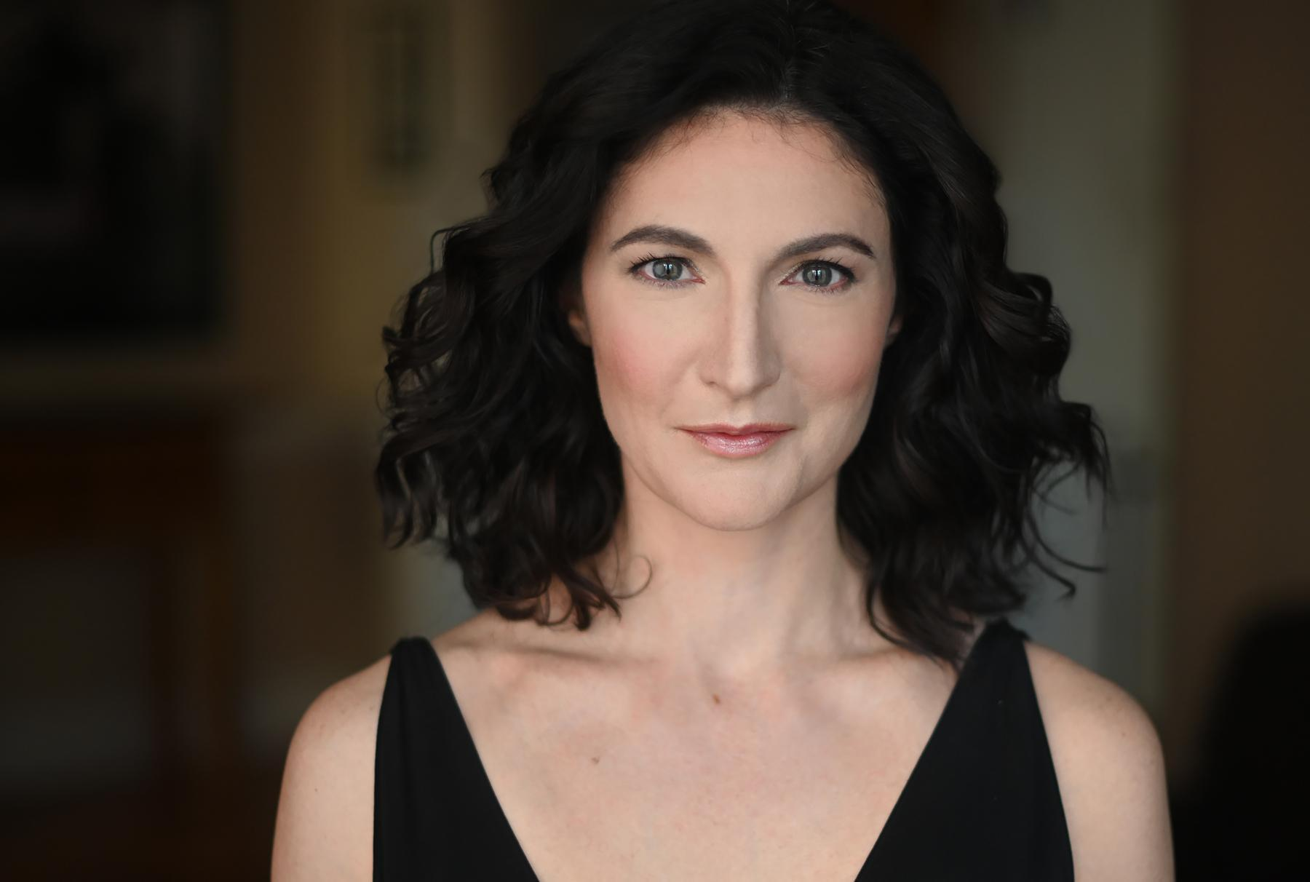
writer / performer - CARLA KISSANE https://www.carlakissane.com
Carla Kissane is an Australian-born, Brooklyn-based actor, singer, and audiobook narrator. A creator and solo performer of Shakespearean cabaret, Carla received a New York State Council on the Arts award for PETTY TYRANT in 2024. Recent work in NYC includes ‘The Tiniest Thing’ and ‘Stranded’ for the Australian Theatre Festival, solo shows ‘Unbecoming’ and ‘Whores & Weeping Women’ and the title role in ‘Medea’, directed by Miriam Grill. Notable Australian productions include Sondheim's ‘Saturday Night’ (Australian Premiere), six shows with the Australian Shakespeare Company, and ‘Motherhood The Musical’ (National Tour). AEA, SAG-AFTRA.
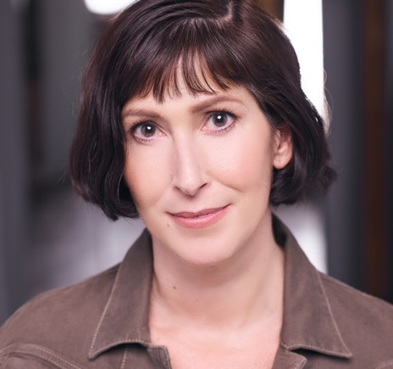
DRAMATURG – PROFESSOR CAROL SYMES studies the mediation of knowledge in, and about, the medieval world: the history of premodern media as well as the processes by which products and perceptions of the medieval past are transmitted to future generations. She has published widely on the medieval reception and preservation of ancient dramatic texts; the role of medievalism in modern cultural trends, intellectual projects, and nationalist historiographies; and, most importantly, on the material, embodied, performative, and negotiated processes of writing across an array of medieval genres. She is also a public-facing theatre scholar and practitioner who has produced and performed in numerous actor-friendly verse translations of medieval plays. Carol received the Ph.D in History from Harvard and became a member of Actors’ Equity in the same year. She also holds a B.A. in Humanities from Yale and an M.Litt in History from Oxford, and received her professional training as an actor at the Bristol Old Vic Theatre School. View CV
TECHnical specs and touring information
Running time: 45- 50 minutes no intermission. Option for a 1 hour version also.
Bump in/out times: Ideally 15 mins either side with a 2 hour technical rehearsal

Staging: This production is very adaptable to various performance spaces.
The show is a solo performance by Carla Kissane: actor/singer, writer, producer.

Set pieces: A small table for water, DSL. A music stand or coat rack, USR. A 13mm mic stand with perform VE / vocal effect processor, hidden behind a wooden book. (approximately 3-4 feet), CS.

FX: A dinner bell and gong are played offstage throughout as a ‘reset’ throughout the show.

Personal Props: 2 wooden books, each containing papers and confetti -the smaller is preset on the music stand and the larger by the CS microphone stand.
A conductor’s baton, preset USC, and used by the actor throughout.
Audience text pieces are preset on the table DSR. A kazoo is played by the actor. A small tea light (LED) is used at top of show. A glass of water on a small table DSL (drunk from throughout the show).

Costume Pieces: Shakespeare’s Doublet is alternatively worn as a costume piece or stored on the music stand throughout the show.

Accompaniment: The show can be performed solo with vocal effects processor, or with live musicians, (one musician - piano / keyboard), or live 3 piece band (piano / drum kit / double bass)

Audio: Wireless microphone and stand is needed, connected to the sound desk.
Headset / lavalier microphone may also be required, depending on orchestration and size of venue, patched into the sound desk. Small venue would be appropriate. (50-100 seats optimal)

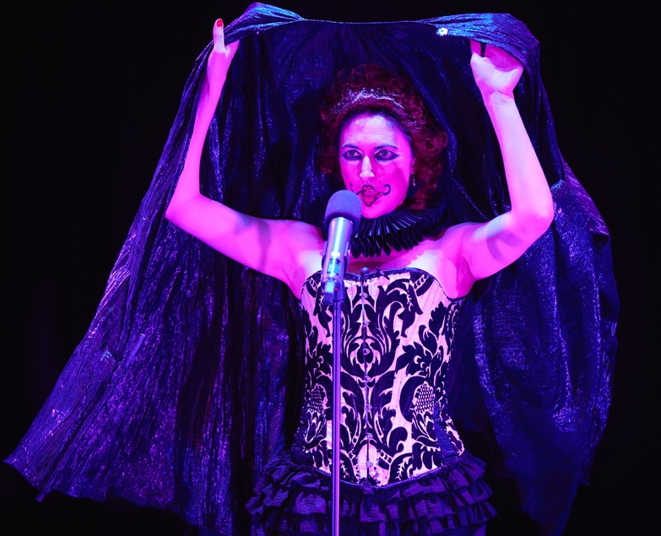
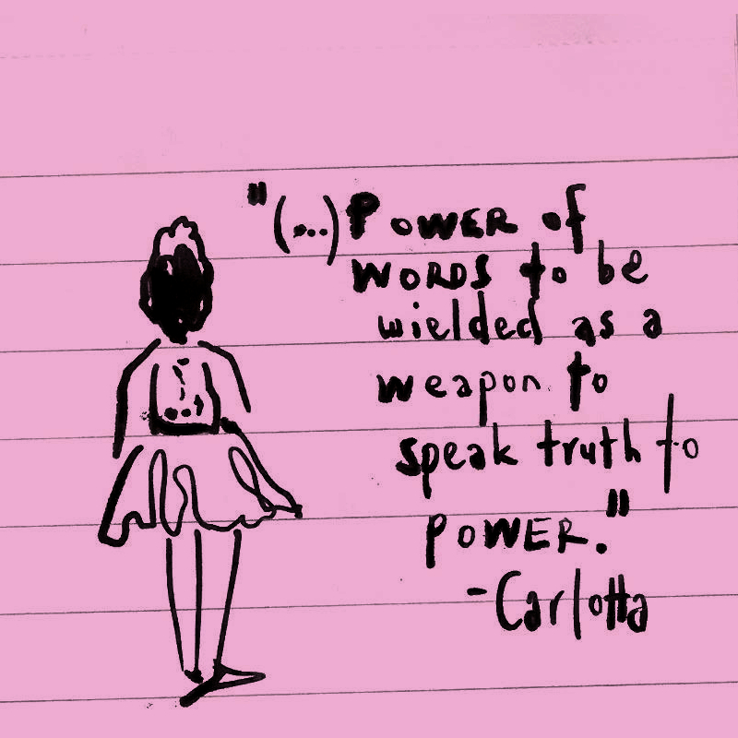

Touring Info
There are two - five members of the touring party.
Performer Carla Kissane, Stage Manager, potential for pianist, or 3 piece band (drume & bass) One venue technician would be ideal to assist with bump in & operate lx /sfx throughout the show. (This was achieved successfully at His Majesty’s Theatre)

Lighting: Ideally a minimum of a 10 channel lighting plot.
Center spot, basic red / blue / green / pink wash, general wash, and house lights.

Dressing rooms: One dressing room would be ideal.

Content Information
The show does NOT contain the following elements:
- strobe lighting
- smoke or haze effects
- smoking
- Hazardous materials
- Flame effect

PETTY TYRANT is recommended for ages 15 years or older and contains some adult content and coarse language

Past productions – ‘unbecoming’
Unbecoming sizzle reel: https://youtu.be/XP8fymTG3yc
Unbecoming ig reels: https://www.instagram.com/shakespeareancabaret/reels/
2022 PRESS RELEASE for ‘unbecoming’ at arts on site, November 17th-18th
2022 Production stills for ‘unbecoming’ at arts on site, november 17th-18th
2022 media and footage for ‘unbecoming’ at arts on site, november 17th-18th

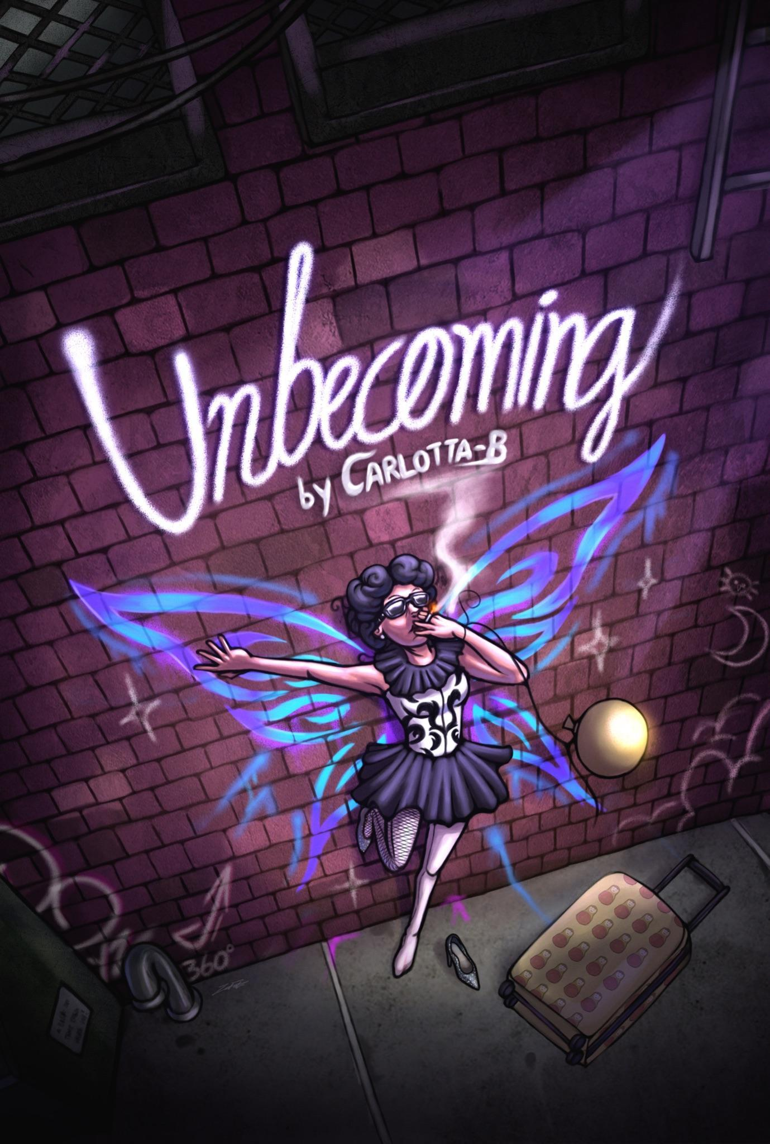
Becoming Carlotta-B is confusing AF!
For the Ultimate Feminist Shakespearean Contemporary Leading Lady, coming to New York City in 2022 from Elizabethan England in 1593 has been both a blessing and a curse.
On the one hand – women are boss ladies!
They’re allowed to read and write and needlework is so five hundred years ago.
On the other hand – Carli-B can’t find any decent hemlock and the Supreme Court has just made life medieval for people with vaginas.
Join Carlotta-B in a protest for freedom that is full of frivolity.
Shakespearean Cabaret Co is a merry band of mischievous artists – cooking up a poetic salve for today’s woes. Written and Performed by Carla Kissane, Directed by Miriam Grill, with musical arrangements by Andrew Patterson & Ben Kiley- our creative team will serve you up a cocktail of musical mashups that is designed to let freedom ring! Hey nonny nonny, Bitches!
PAST PRODUCTIONS - ‘WHORES AND WEEPING WOMEN’
2021 production stills: https://www.shakespeareancabaret.com/production-stills
2021 behind the scenes videos: https://youtu.be/Vuk_tQzIY98
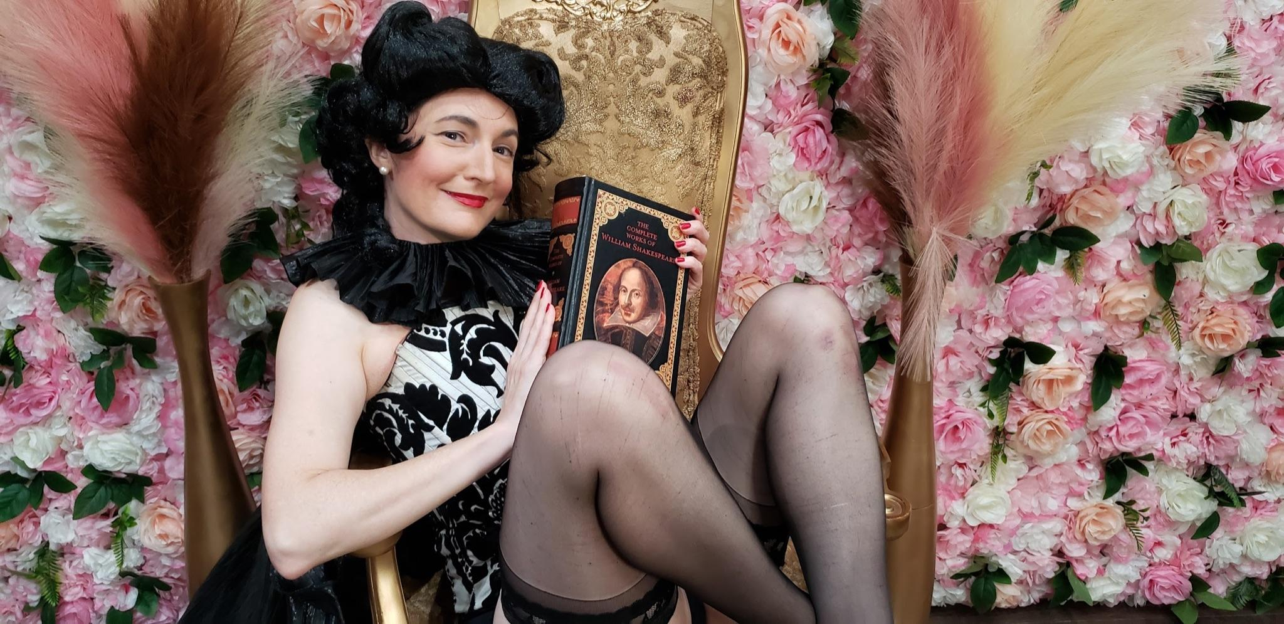
DATES AND VENUES
2021 - arts on site, New York City, USA
2017: duplex cabaret theateR, New York City, USA.
2014 - his majesty’s theatre as part of ‘downstairs at the maj’ - Perth, Australia
2013 - the butterfly club, Melbourne, Australia

creative teams
2021 creative team: : miriam grill, C.S.E Cooney, katherine McClintic, annie Jin wang
2013 creative team: Complete Works Theatre Company, ANDREW BLACKMAN, ANDREW PATTERSON
PHOTOGRAPHIC & IMAGERY CREDITs
JJ IGNOTZ PRODUCTION STILLS 2021 https://jjignotzphotography.com/
NICOLA MENICACCI @SHAKESPEAREANCABARET IG IMAGES https://nicolamenicacci.com/
UNBECOMING POSTER ARTWORK & DESIGN BY IMAN FATE https://www.instagram.com/imvnfate/
east village nyc Photography september 2022 courtesy of https://nicolamenicacci.com/
POSTER IMAGE AND SKETCHES 2024 COURTESY OF MICHELLE BAGINSKI OF https://picklebliss.art
Press & PR
Broadway World June 2023: https://www.broadwayworld.com/off-off-broadway/regional/PETTY-TYRANT-3824952
Broadway World November 2022: https://www.broadwayworld.com/off-off-broadway/regional/Unbecoming-2990772
Broadway World, October 2021: https://www.broadwayworld.com/cabaret/article/Shakespearean-Cabaret-Co-to-Present-WHORES-AND-WEEPING-WOMEN-20211014
The Age, Life & Style, 23rd Nov 2013: http://www.smh.com.au/entertainment/theatre/tame-or-otherwise-the-bards-women-shine-20131121-2xwx5.html#ixzz2lRFiJ4i4
Pop Culture-y, 14th Nov 2013: http://popculture-y.com/2013/11/interview-carla-kissane-in-whores-and-weeping-women/
The Age, 12th Nov 2013: http://www.theage.com.au/entertainment/stage/stage-treading-the-boards-20131111-2xcfs.html
Past Publicity: Eleanor Howlett at Sassy Red PR www.sassyred.com.au

Review of ‘whores and weeping women’
Andrew Fuhrmann, 22nd November 2013: The Age: https://www.smh.com.au/entertainment/theatre/bard-heroines-in-mashup-at-butterfly-club-20131121-2xyjo.html
